**OOPS**

Named group of properties and functions

User defined data type

Class is a template  
Object is an instance of that class

Cannot access elements of class without init => by default null

Student student1; //Declaration

Student student1 = new Student(); //Dynamically allocating memory

Student() is constructor and can pass elements in this  
Student(80,”Sajal”,80.98f)

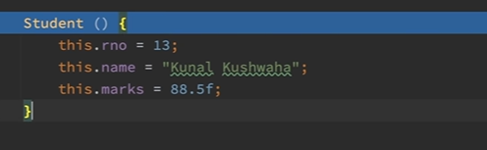

this -> used to access class elements

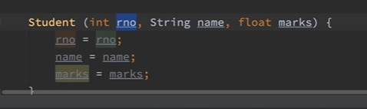

Nothing will happen using above photo(default values)  
Do this.rno=rno

Primitive data types are in stack only (No dynamic memory allocation)  
Non primitive in heap

final keyword is used to not modify a value like const

final int a=5;

final variables must be initialized while declaration

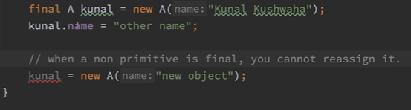

Cant use destructor in java to free memory due to automatic garbage collection  
so use finalize keyword that helps to tell what needs to be done when memory is freed